APPLICATION
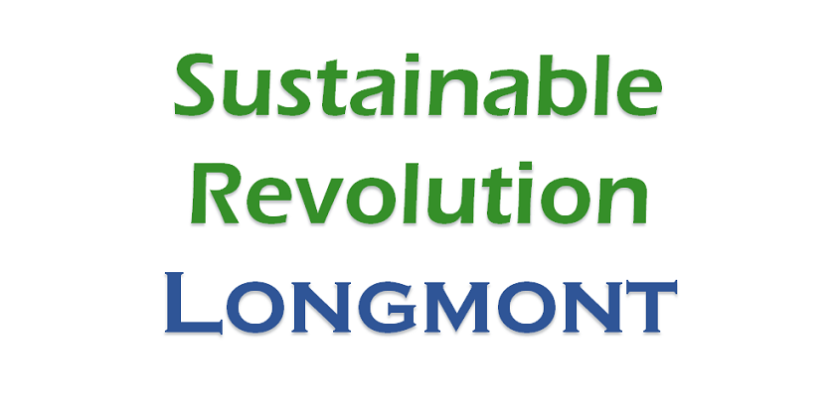
Youth of the Earth Council
For Planning the Boulder County Youth Earth Day event
2014/2015

Position description:
Do you want to be a key part of the 1st Annual Boulder County Youth Earth Day event? Are you interested in reaching out to and inspiring other youth to improve the environment and showcase their efforts on Earth Day? Do you have skills as an organizer, money manager, writer, graphic designer, social media guru, musician or artist? Ready to put those skills to work for the environment? Does planning a youth-led, youth-focused event sound like a blast? If so, we want you!

We are seeking motivated youth to represent all areas and all backgrounds in Boulder County, to work together to design the Boulder County Youth Earth Day event that will be held on April 22, 2015 at the Boulder County Fairgrounds in Longmont. The council will name the event, design the logo and theme, design the event programming, and decide on the criteria for Youth Booths, art and music. The council will also be the primary outreach for encouraging participation in the event by youth. The council will work in partnership with the adult event coordinators on planning logistics and finding sponsors. Seeking: 12 Youth Leadership Council members

Requirements:
- Youth (up to age 25);
- Resident of Boulder County (preferred);
- Ability to work cooperatively with youth from preschool through college age, and facilitator;
- Passionate about improving the environment;
- Attend April 22, 2015 to be at the Boulder County Fairgrounds from approximately 3 – 8 pm;
- Attend monthly meetings on Saturday afternoons in Longmont, October 2014 – April 2015;
- Perform 2-4 hours of additional work or activities between the monthly meetings, September 2014 – April 2015;
- Willing to take responsibility for a key component of the Earth Day event;
- Willing to work with others diligently and enthusiastically to form a healthy, productive Youth Leadership Council;
- Willing to reach out to other youth by presenting to classes, schools, and other groups, as well as through a variety of media;
- Willing to help with fundraising, grant writing and developing sponsors;
- Works as a positive, encouraging, supportive team member that enjoys hard work and fun!

About Sustainable Revolution Longmont
Sustainable Revolution Longmont is a new environmental group dedicated to improving the environment in Longmont and beyond. We learn, teach, advocate and act, working collaboratively and inclusively with all ages and backgrounds. We have reserved the Fairgrounds and are taking primary responsibility for grant writing and fundraising to support the event.

Application Instructions:
Our application process has two steps:
Step 1: Attend an introductory meeting on September 13, 3 - 5pm at the Longmont Library or complete an in-person interview.
Step 2: Submit application to EarthDay@SRLongmont.org. You may use additional space, attach links or work samples.

application for earth day youth leadership council 2014/2015

part 1: General info

YOUTH Information (up to age 25)
First name: | Last name:
Date of birth: | Grade:
E-mail address: | Phone:
Mailing address:
School:

PARENT/GUARDIAN INFORMATION (for youth up to age 18)
First name: | Last name:
E-mail address: | Phone:
Mailing address:
Relationship:

additional aUTHORIZED PICK UP PERSON/EMERGENCY CONTACT INFORMATION
First name: | Last name:
E-mail address: | Phone:
Mailing address:
Relationship:

HEALTH & BEHAVIOR INFORMATION
Allergies, reactions, health concerns or chronic health issues:

Behavior concerns or “Need to Knows”:

Additional parent comments:

Parent/GUARDIAN Signature (for youth up to age 18)
I give permission for my child to participate in the Earth Day Youth Leadership Council. I have read the Position Description and if my child is selected, I agree to assist my child by providing or finding transportation to monthly meetings, additional optional activities, and the Earth Day event.

Signature of parent/guardian: |  | Date:

part 2: youth questionnaire

(feel free to Use additional space, add attachments, links or samples of your work and creativity!)

Availability and commitment
Will you be able to attend the introductory meeting or participate in an in-person interview?

Will you be able to attend monthly meetings on the second or third Saturday of the month in Longmont from October through April? Meetings will take place in late afternoon or early evenings. (Usually 3-6pm)
Are you willing to enthusiastically complete tasks requiring 2-4 hours of additional time between each monthly meeting?
Will you be able to attend the Earth Day event on April 22, 2015 at the Boulder County Fairgrounds from approximately 3-8 pm? The event will be from 4-7 pm.

motivation and passion
Why would you be awesome on the Council?

Are you passionate about the environment? What have you done? What would you like to learn about? What would you like to do?

teamwork and communication
Are you patient, hardworking and fun?
Will you respond to emails and phone calls?
Are you able to adjust and go with the flow?
Do you enjoy working in a group? Team player?
What role would you most like to have in the group?
Member, Chair, Co-Chair, Secretary, Treasurer, Media
What responsibilities would you like to take on?

experience and skills
What skills would you bring to the Council?
Examples: Social media guru, graphic designer, videographer, artist, musician, community organizer, money manager, promoter, leader, researcher, event coordinator, fundraiser, writer, grant writer, public speaker, environmental activist, scientist, builder.
Give examples of your work and community experience that show you have the motivation and skills to work effectively on a team.
Who will you reach out to about this event? Which groups, schools, community and businesses would you contact to partner or support this event?
What are your strengths and weaknesses?

What else would you like to tell us about yourself?
(Optional: You may attach additional information, links or sample of your work if you’d like.)

youth Signature
I have read the Position Description and agree to enthusiastically and diligently perform the duties. If selected, I will attend the monthly meetings, the Earth Day event and perform additional tasks between meetings. I will plan ahead and arrive on time to each meeting. I will be a positive, hardworking, fun team player. I will spread the word about the Earth Day event. I will do my part to make Earth Day 2015 fabulous!
Signature of youth: |  | Date:

